**Claim (Renamed To Own Damage) Tab Layout**

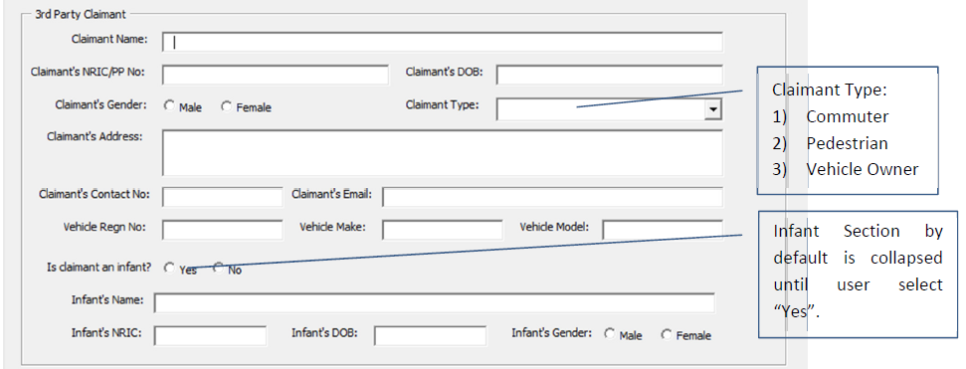

Unique Subset Number of Parent Claim Number (generated from Accident Tab), e.g. C00001-OD01

Set To Own Damage

Add 4) Company

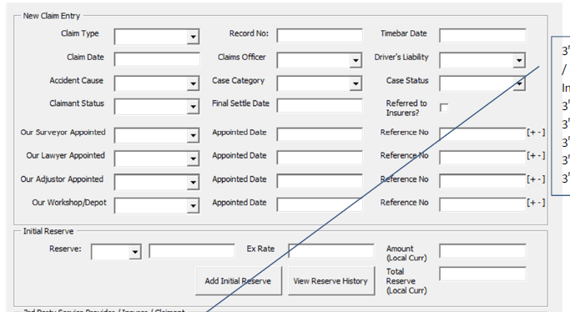

Add Recoverable (OD) : Yes / No

If yes, this Claim Record will flow to Claims Recovery Processing after User clicks on Complete Button

Claimant Status:

Input:

* Pending
* Finalized
* Cancelled
* Reopened

Initial Reserve (Popup)

Populate from Total Field Of Popup

**Initial Reserve (Popup)**

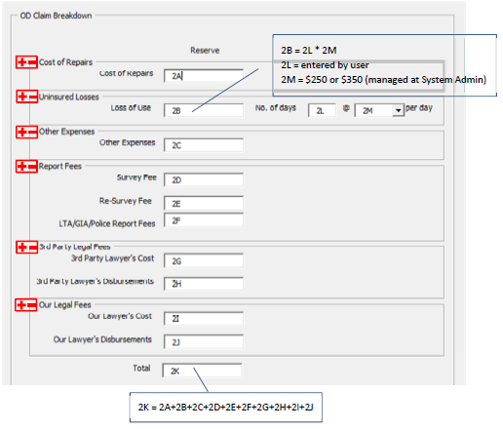

Save Button

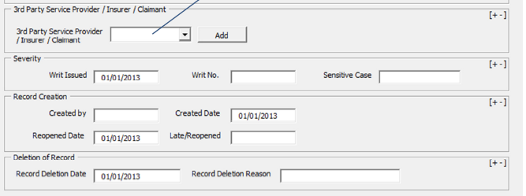

Third Party Service Provider Popup

But do we need to create display tables for the saved entries?

Field Open when Claimant Status = Cancelled

Field Open when Claimant Status = Reopened

**Third Party Service Provider (Popup)**

